1. 1.What is the difference between clustering and classification?
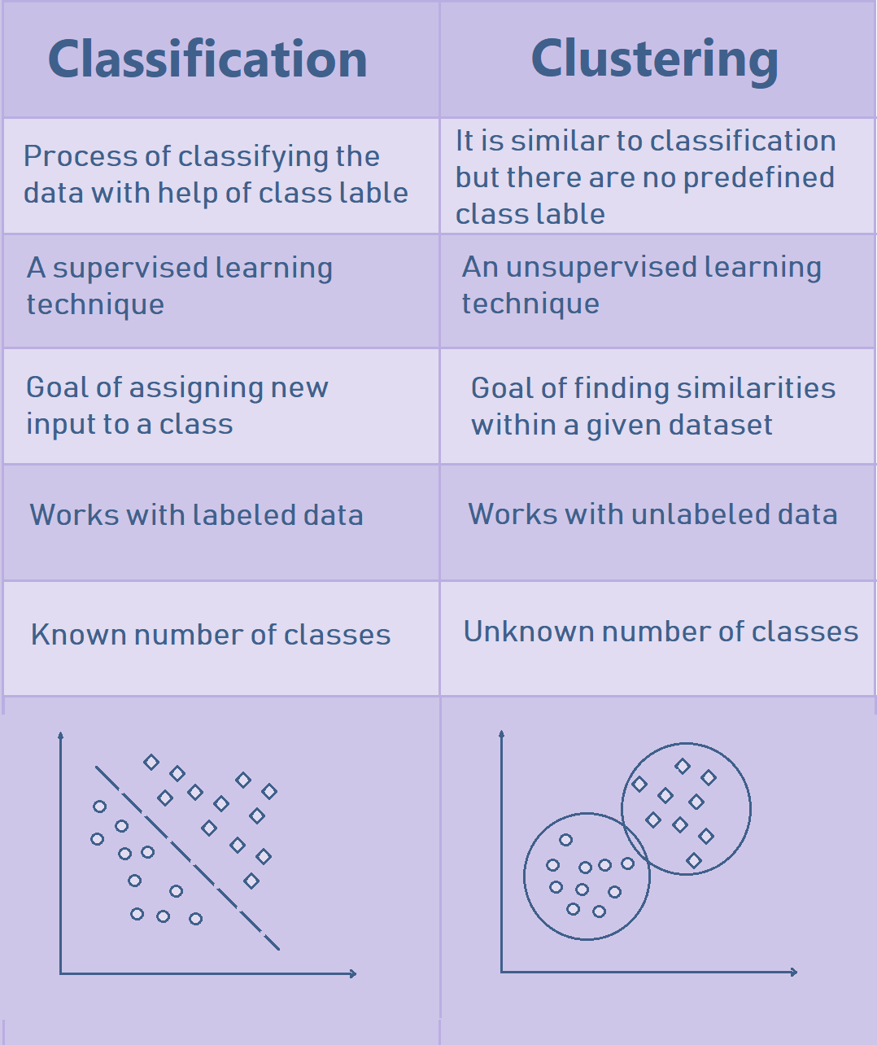

2.What is Machine Learning?
A model to gain knowledge and predict for upcoming data.

3.What is Supervised, Unsupervised and reinforcement learning?
Supervised-labelled does classification
unsupervised-not labeled finds similarity
reinforcement-continous learning by reward and penalty
4.Collection of Data, Data preprocessing?
Collection of data-identifying sources,data quality,new features
Data preprocessing- data cleaning,filtering,removing outliers
5.Data validation vs testing ?
Validation set is used for determining the parameters of the model,
and test set is used for evaluate the performance of the model
6.What is centroid in kmeans and how do u determine ?
Centroid- imaginary center of cluster
By averaging the data points feature wise

7. What is the difference between underfitting and overfitting in machine learning models?
8. What is the key component of a decision tree that represents a decision based on a feature?
9. Difference between AI, ML, and DL?
Definition | AI is the broader technology that enables machines to simulate human intelligence and decision-making. | ML is a subset of AI that allows systems to automatically learn patterns from data and improve performance. | DL is a subset of ML that uses multi-layer neural networks to learn complex patterns from massive datasets.
Core Goal | Make machines think and act like humans. | Enable machines to learn from data without explicit programming. | Enable machines to learn complex representations automatically.
Technology Scope | Broad field including ML, robotics, NLP, computer vision, and reasoning systems. | Focused on algorithms that learn from historical data. | Focused on deep neural network architectures.

10. What is an A* algorithm search method?
A* is a computer algorithm that is extensively used for the purpose of finding the path or traversing a graph in order to find the most optimal route between various points called the nodes.
11. What is a breadth-first search algorithm?
A breadth-first search (BFS) algorithm, used for searching tree or graph data structures, starts from the root node, then proceeds through neighboring nodes, and further moves toward the next level of nodes.
12. Differentiate between supervised, unsupervised, and reinforcement learning.
ifferentiation Based on | Supervised Learning | Unsupervised Learning | Reinforcement Learning
Features | The training set has both predictors and predictions. | The training set has only predictors. | It can establish state-of-the-art results on any task.
Algorithms | Linear and logistic regression, support vector machine, and Naive Bayes | K-means clustering algorithm and dimensionality reduction algorithms | Q-learning, state-action-reward-state-action (SARSA), and Deep Q Network (DQN)
Uses | Image recognition, speech recognition, forecasting, etc. | Preprocessing data, pre-training supervised learning algorithms, etc. | Warehouses, inventory management, delivery management, power system, financial systems, etc.

13. What is the difference between inductive, deductive, and abductive Machine Learning?
Inductive Machine Learning | Deductive Machine Learning | Abductive Machine Learning
Learns from a set of instances to draw a conclusion | Derives the conclusion and then improves it based on the previous decisions | It is a Deep Learning technique where conclusions are derived based on various instances
Statistical Machine Learning, such as KNN (K-nearest neighbor) or SVM (Support Vector Machine) | Machine Learning algorithm using a decision tree | Deep neural networks
A ⋀ B ⊢ A → B (Induction) | A ⋀ (A → B) ⊢ B (Deduction) | B ⋀ (A → B) ⊢ A (Abduction)

14. What is overfitting? How is overfitting fixed?
Overfitting is a situation that occurs in statistical modeling or Machine Learning where the algorithm starts to over-analyze data, thereby receiving a lot of noise rather than useful information. This causes low bias but high variance, which is not a favorable outcome.
Overfitting can be prevented by using the following methods:
- Early stopping
- Ensemble models
- Cross-validation
- Feature removal
- Regularization
15. What is model accuracy and model performance?
Model accuracy, a subset of model performance, is based on the model performance of an algorithm. Whereas model performance is based on the datasets we feed as inputs to the algorithm.
16. Define F1 score.
The F1 score is the weighted average of precision and recall. It considers both false positive and false negative values into account. It is used to measure a model’s performance.
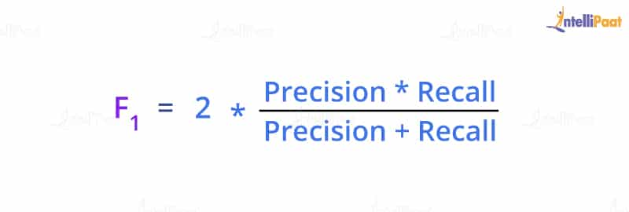
17. List the steps involved in Machine Learning.
- Data collection
- Data preparation
- Choosing an appropriate model
- Training the dataset
- Evaluation
- Parameter tuning
- Predictions
18. What is a perceptron in Machine Learning?
Perceptron is an algorithm that is able to simulate the ability of the human brain to understand and discard; it is used for the supervised classification of the input into one of the several possible non-binary outputs.
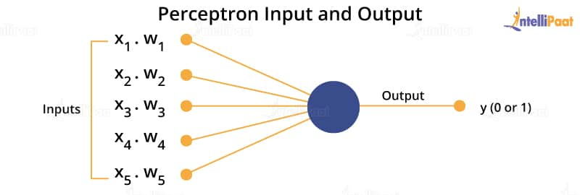
19. List the applications of Machine Learning.
- Image, speech, and face detection
- Bioinformatics
- Market segmentation
- Manufacturing and inventory management
- Fraud detection, and so on
20. 1. Data Set - A dataset is a collection of data in which data is arranged in some order. A
dataset can contain any data from a series of an array to a database table.

21. Model - A data structure that store representation of A data set models are creative when
you train a algorithm on a data set.

22 Noise - Any irrelevant information is called Noise.

23. Outliner - An observation that significantly from other observation in the data set.

24. Desk Set - A set of observation used at the end of model training and validation to access.
The predictive power of your model.
25. Training - A set of observation used to generate machine learning model.

26. Data collection - Collect the data that the algorithm will learn from.

27. Data preparation - Format the data into the optical form.
28. Data Visualization - Data visualization is the graphical representation of information and
data in a pictorial or graphical format(Example: charts, graphs, and maps). Data
visualization tools provide an accessible way to see and understand trends, patterns in
data, and outliers. Data visualization tools and technologies are essential to analyzing
massive amounts of information and making data-driven decisions.
29. Pandas - Pandas is a software library written for the Python programming language for
data manipulation and analysis. In particular, it offers data structures and operations for
manipulating numerical tables and time series.
30 NumPy - Numpy is a library for the Python programming language, adding support for
large, multi-dimensional arrays and matrices, along with a large collection of high-level
mathematical functions to operate on these arrays.

31. Datapoints - Values are organised in structures called datapoints.
32. Linear regression
Linear regression is one of the easiest and most popular Machine Learning algorithms. It is a
statistical method that is used for predictive analysis. Linear regression makes predictions for
continuous/real or numeric variables such as sales, salary, age, product price, etc
33. Types of SVM
o Linear SVM: Linear SVM is used for linearly separable data, which means if a dataset
can be classified into two classes by using a single straight line, then such data is
termed as linearly separable data, and classifier is used called as Linear SVM classifier.
o Non-linear SVM: Non-Linear SVM is used for non-linearly separated data, which
means if a dataset cannot be classified by using a straight line, then such data is
termed as non-linear data and classifier used is called as Non-linear SVM classifier.
34. Decision Tree Classification Algorithm
1. Decision Tree is a Supervised learning technique that can be used for both
classification and Regression problems, but mostly it is preferred for solving
Classification problems. It is a tree-structured classifier, where internal nodes
represent the features of a dataset, branches represent the decision
rules and each leaf node represents the outcome
2.in a Decision tree, there are two nodes, which are the Decision Node and Leaf
Node. Decision nodes are used to make any decision and have multiple branches,
whereas Leaf nodes are the output of those decisions and do not contain any further
branches.
3. The decisions or the test are performed on the basis of features of the given dataset.
4. It is a graphical representation for getting all the possible solutions to a
problem/decision based on given conditions.

35. Underfitting
Underfitting occurs when our machine learning model is not able to capture the
underlying trend of the data. To avoid the overfitting in the model, the fed of training data
can be stopped at an early stage, due to which the model may not learn enough from the
training data. As a result, it may fail to find the best fit of the dominant trend in the data.
36. Overfitting
Overfitting occurs when our machine learning model tries to cover all the data points or
more than the required data points present in the given dataset. Because of this, the
model starts caching noise and inaccurate values present in the dataset, and all these
factors reduce the efficiency and accuracy of the model.
37. Association rule
Association rule mining Association rule mining finds interesting associations and
relationships among large sets of data items. This rule shows how frequently a itemset
occurs in a transaction. A typical example is a Market Based Analysis
38. How would you create a chatbot? Explain the process.
Ans.
To make a chatbot, you need to design the conversation flow, integrate natural language processing, and train the bot with relevant data.
- Design the conversation flow with a clear structure and user-friendly interface
- Integrate natural language processing to understand user inputs and generate appropriate responses
- Train the chatbot with relevant data to improve accuracy and effectiveness
- Implement features like sentiment analysis, entity recognition, and context awareness for better user experience
39. How would you create a chatbot? Explain the process.
Ans.
To make a chatbot, you need to design the conversation flow, integrate natural language processing, and train the bot with relevant data.
- Design the conversation flow with a clear structure and user-friendly interface
- Integrate natural language processing to understand user inputs and generate appropriate responses
- Train the chatbot with relevant data to improve accuracy and effectiveness
- Implement features like sentiment analysis, entity recognition, and context awareness for better user experience
40.

